IT RCSA Audit Documentation
Vendor Defaults – BSI.IT.10.C11
Design Assessment, Walkthrough and Sample of One (mia-dc-analytics – Linux, in period / MIA-DC-SQLPRD01 – Windows)
DESIGN RATING | SAMPLE | OBSERVATIONS
SATISFACTORY | mia-dc-analytics  MIA-DC-SQLPRD01  PASS (setting) | 4

Control | BSI.IT.10.C11 – Vendor Defaults (Key, Semi-Automated, In every operation)
Review period | 07/01/2025 – 06/30/2026 (evidence captured 10/30/2026)
Walkthrough | IT RCSA (Edward Morfa) met with Ian Rojo (control owner) and [Infrastructure participants – to be confirmed] on [walkthrough date - to be confirmed]
Sample of one | One server per build path: mia-dc-analytics (RHEL, manual build; CMDB Installed 09/18/2025 – in period) and MIA-DC-SQLPRD01 (Windows, gold image / GPO; CMDB Installed 05/14/2025 – before the period, used for the Windows design because no in-period Windows export has been received yet).
Evidence folder | CDA/C11_CDA_Evidence and CPA/C11_CPA_Evidence. Start with BSI.IT.10.C11_E00_Evidence Index.xlsx.

Control description
[BSI.IT.10.C11 Vendor Defaults] In every operation, Infrastructure teams change vendor default passwords for root or administrator accounts on Operating Systems before the server reaches install status in CMDB.

How to use this document
All files sit in this control's CDA and CPA folders, named by E-number (for example C11_CPA_Evidence / E02). The E00 Evidence Index lists every file with its MD5. Each result in Section 3 names its evidence and where to look. Section 4 lists every place the sample appears. Results read: Pass (green), Fail (red), Observation / Open (amber - not an exception).

Evidence References
Ref | Evidence | Used for
CDA E01 | Secure Build and Configuration Management Standard v8.0 (07/28/2026) | SUS.SBS.4.2.3.4 (p.11), 4.2.1.4 (p.5), 4.2.1.5–4.2.1.6 (p.6)
CDA E02 | Windows Server Hardening Guide v6.0 (09/17/2026) | Rename Administrator / Guest
CDA E03 | Linux RHEL Hardening Guide v3.0 (01/05/2026; file named "1.5") | Sec. 4.3 Out of Scope, 4.2.19 PermitRootLogin (p.31)
CDA E04 | Coverage Period 2026 | Period 07/01/2025 – 06/30/2026
CPA E01 | Windows security exports (5) | MIA-DC-SQLPRD01_SecExport.txt
CPA E02 | Linux PermitRootLogin captures 10/30/2026 | mia-dc-analytics – 1st screenshot
CPA E06 / E07 | CMDB extract (294 Installed servers, query 11/04/2026) and CMDB Population Analysis | Installed dates; in-period population of 27
CPA E05 | SEF exceptions 07/01/2025 – 07/04/2026 | Blank file

1. Design Effectiveness Summary
The control design is effective. Trigger: every server build, before the server goes to Installed in CMDB (CDA E01, SUS.SBS.4.2.1.4). Windows servers are built from the gold image and group policy renames the built-in Administrator and Guest accounts and disables Guest (CDA E02). Linux (RHEL) has no vendor default root password; root is set at build and PermitRootLogin is set to no. Criteria: change or disable all default accounts and passwords (CDA E01, SUS.SBS.4.2.3.4). Monitoring: InfoSec scans at least quarterly; anything that can't be changed needs a CISO-approved SEF exception (SUS.SBS.4.2.1.5–4.2.1.6).
Overall Rating: Satisfactory, with observations: (1) nothing links the date of the change to the CMDB install date, so we can confirm the setting but not that it came before install status; (2) the Linux guide v3.0 lists PermitRootLogin in sec. 4.3 Out of Scope, while the servers still have it set to no; (3) the SEF export for the period is blank and needs confirmation.

2. WT Summary
IT RCSA met with Ian Rojo (control owner) and [Infrastructure participants – to be confirmed] on [walkthrough date - to be confirmed]. The owner confirmed the process is unchanged from 2025, except that the 2026 statement covers OS accounts only; database defaults moved to BSI.IT.10.C10.
- Windows build: server imaged from the BSI gold image and joined to the domain; GPO renames Administrator and Guest to BSI names and disables Guest. The setting is visible in the secedit security export.
- Linux build: Linux admin sets the root password during install and sets PermitRootLogin no in /etc/ssh/sshd_config. Visible with grep -i permitroot /etc/ssh/sshd_config.
- CMDB: the server is moved to Installed only after the build steps are done.
- Exceptions: if a default can't be changed, Infrastructure raises a SEF exception for CISO approval.
Sample of one: mia-dc-analytics and MIA-DC-SQLPRD01 were checked against the criteria. Results are in Section 3 and every location is listed in Section 4.
Based on the walkthrough, the control appears to be designed appropriately. For both items the default administrator / root access was changed or locked down as described.

3. Sample of One – mia-dc-analytics (Linux) and MIA-DC-SQLPRD01 (Windows)
Workpaper column | Value / conclusion | Evidence reference | Result
"change vendor default ... administrator accounts" – Windows Administrator renamed (A1) | NewAdministratorName is a BSI name, not "Administrator" (name withheld) | CPA E01 MIA-DC-SQLPRD01_SecExport.txt, [System Access] | Pass
Windows Guest renamed and disabled (A1) | NewGuestName is a BSI name; EnableGuestAccount = 0 | CPA E01, [System Access] | Pass
"root ... accounts" – Linux root SSH login (A1) | mia-dc-analytics: PermitRootLogin no (10/30/2026 11:54 AM) | CPA E02, 1st screenshot | Pass
"before the server reaches install status in CMDB" (A2) | Settings are current captures; CMDB install date not yet received | CMDB extract outstanding (OI-2) | Open
Exception approved by CISO (if not changed) | Not needed – both items changed; SEF export blank | CPA E05 | Pass
Export date | Windows export has no date inside | CPA E01 | Observation
Guide coverage (Linux) | Guide v3.0 sec. 4.3 lists PermitRootLogin as Out of Scope; server still compliant | CDA E03 p.31 | Observation
Built in the period? | mia-dc-analytics: CMDB Installed 09/18/2025 – in period. MIA-DC-SQLPRD01: CMDB Installed 05/14/2025 – before the period (support for the Windows design only) | CPA E06; E07 tab Sample lookup | Pass (Linux) / Observation (Windows)
CMDB install date reliable? | Installed date = record creation date for 285 of 294 servers; SQLPRD01 was "Pending install" in the 2025 C19.03 list but shows 05/14/2025 here. Can't show the date status changed | CPA E07 tabs Summary, Install vs created | Observation
Export tied to the server | MIA-DC-SQLPRD01 host name appears inside the export (SQL Browser account) | CPA E01 | Pass
Conclusion: Sample mia-dc-analytics and MIA-DC-SQLPRD01 PASSED attribute A1 (setting). Administrator and Guest were renamed and Guest disabled on the Windows server, and root SSH login was off on the Linux server, in line with SUS.SBS.4.2.3.4. mia-dc-analytics is an in-period build; MIA-DC-SQLPRD01 is not, so it supports the design only. Attribute A2 (before CMDB install status) can't be tested from CMDB, because its Installed date is the record creation date; build tickets have been requested.

4. Evidence Locator – where to find the samples
Ref | Evidence | What it shows
CDA E01 | Secure Build Standard v8.0 – SUS.SBS.4.2.3.4 (p.11), 4.2.1.4 (p.5) | Criteria
CDA E02 | Windows Server Hardening Guide v6.0 | Rename Administrator / Guest
CDA E03 | Linux RHEL Hardening Guide v3.0 – sec. 4.3, 4.2.19 (p.31) | PermitRootLogin listed Out of Scope
CPA E01 | MIA-DC-SQLPRD01_SecExport.txt – [System Access] lines | Renamed accounts, Guest disabled (Exhibit A1)
CPA E02 | PermitRootLogin_settings_20261030 – screenshot 1 | mia-dc-analytics PermitRootLogin no (Exhibit A2)
CPA E06 / E07 | CMDB extract row mia-dc-analytics; E07 tab C11 population row 1 | Installed 09/18/2025 (Exhibit A4)
CPA E05 | SEF export | Blank – no exceptions listed
WP2 | WP2 BSI.IT.10.C11 Vendor Defaults 2026.xlsm – CPA tab rows 52–56, 72–76 | Same results in workpaper form

Appendix A – Sample Evidence
Exhibit A1: MIA-DC-SQLPRD01 security export – [System Access] excerpt (CPA E01)
NewAdministratorName = "[withheld - confidential]"
NewGuestName = "[withheld - confidential]"
EnableAdminAccount = 1
EnableGuestAccount = 0
Source: CPA E01 – MIA-DC-SQLPRD01_SecExport.txt. Account names withheld here for confidentiality; the full value is in the file and is not "Administrator" or "Guest".
Exhibit A2: mia-dc-analytics – PermitRootLogin (CPA E02)
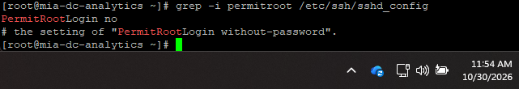
Source: CPA E02 – PermitRootLogin_settings_20261030.docx, screenshot 1. Screen clock 10/30/2026 11:54 AM.
Exhibit A3: Other Linux samples (CPA E02)
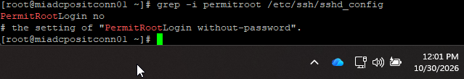
Figure A3-1. miadcpositconn01 – PermitRootLogin no (10/30/2026) – built before the period.
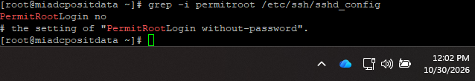
Figure A3-2. miadcpositdata – PermitRootLogin no (10/30/2026) – built before the period.
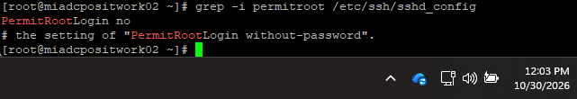
Figure A3-3. miadcpositwork02 – PermitRootLogin no (10/30/2026) – built before the period.
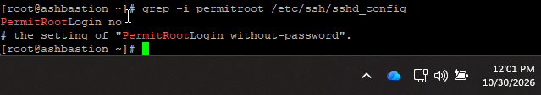
Figure A3-4. ashbastion – PermitRootLogin no (10/30/2026) – built before the period.
Exhibit A4: CMDB – mia-dc-analytics (CPA E06)
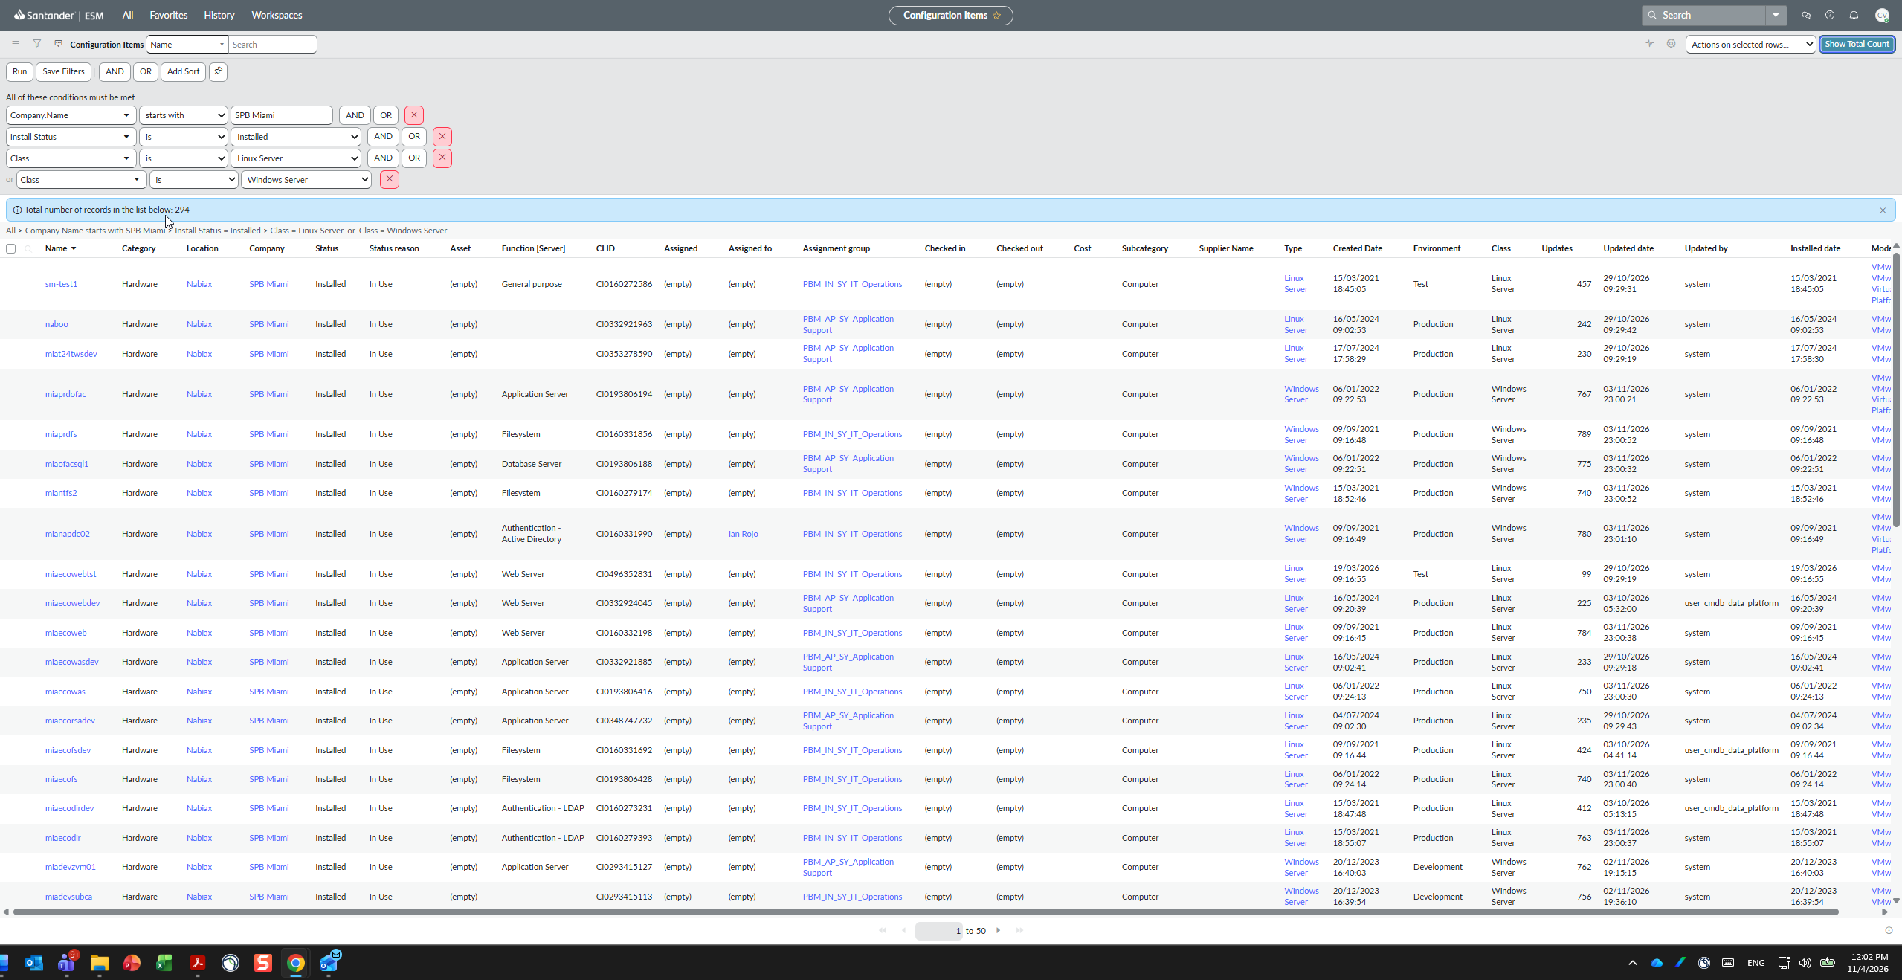
Source: CPA E06 – query screenshot in the CMDB extract: Company starts with SPB Miami, Install Status = Installed, Class = Linux Server or Windows Server; 294 records; 11/04/2026 12:02 PM.
Name | Type | Environment | Created | Installed date | Assignment group
mia-dc-analytics | Linux Server | Production | 09/18/2025 | 09/18/2025 | PBM_IN_SY_IT_Operations
Package: CDA and CPA evidence folders, E00 index, WP2 2026 workbook and this document.

